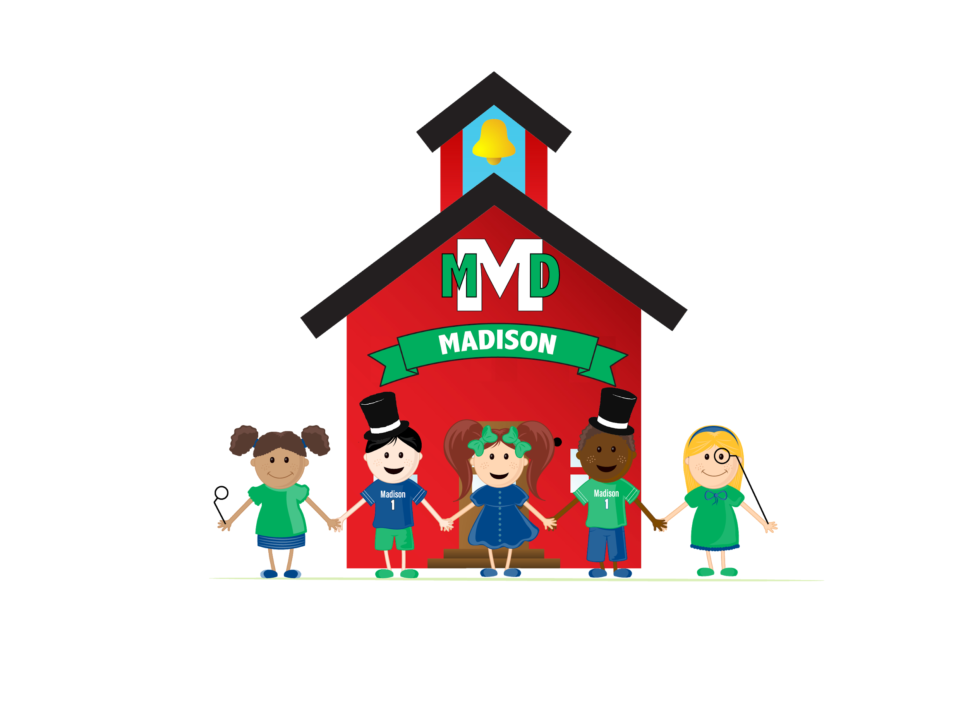

MADISON EARLY CHILDHOOD EDUCATION CENTER
130 W. Madison Street
Elmhurst, Illinois 60126

(630) 617-2385• Fax: (630) 617-8212

Ms. Susan Kondrat - Principal

2019-2020 AM Student Supply List

1 full-sized backpack
1 notebook to keep in backpack
1 full set of extra clothing--please put in a ziplock bag with your child’s name on it

1 24-ct. box Crayola Crayons
1 4-oz. bottle Elmers Glue
2 100-ct. boxs 5 oz. Dixie Cups—NOT 3 oz.
2 300-ct. package paper napkins
2 rolls paper towels
1 100-ct. package baby wipes
1 disposable plastic tablecloth (size: 54 x 108 inches)
1 4-pack Play-Doh 20-oz. size
1 30-oz. bag or bottle popcorn kernels--not popped

Boy Students please also bring 1 box of 2 Gallon Ziploc Bags
Girl Students please also bring 1 box of Sandwich Size Ziploc Bags

Wish List Items for Sensory Play:
paper shred
bag of dirt—organic, fertilizer free
kinetic sand
premium play sand

MADISON EARLY CHILDHOOD EDUCATION CENTER
130 W. Madison Street
Elmhurst, Illinois 60126

(630) 617-2385• Fax: (630) 617-8212

Ms. Susan Kondrat - Principal

2019-2020 PM Student Supply List

1 full-sized backpack
1 notebook to keep in backpack
1 full set of extra clothing--please put in a ziplock bag with your child’s name on it

1 8-ct. box THICK Crayola Markers
1 4-ct. pack Play-Doh 20-oz. size
2 100-ct. box 5 oz. Dixie Cups—NOT 3 oz.
2 rolls paper towels
1 200-ct. box Tissue
1 300-ct. package paper napkins
2 100-ct. package baby wipes
1 disposable plastic tablecloth (size: 54 x 108 inches)
1 16-oz. or larger bag dried black beans

Boy Students please also bring 1 2-pack glue sticks
Girl Students please also bring 1 set 8-color watercolors

Wish List Items for Sensory Play:
paper shred
bag of dirt—organic, fertilizer free
kinetic sand
premium play sand

